Spiriluna

## Graph

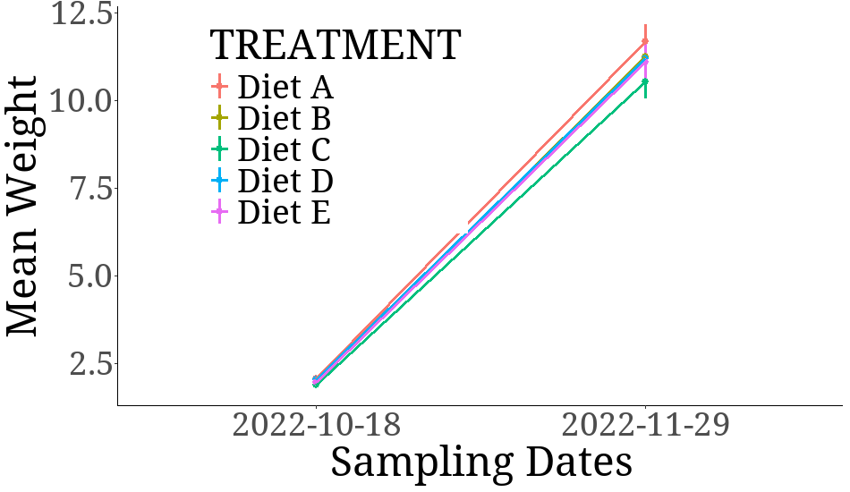

## Bars

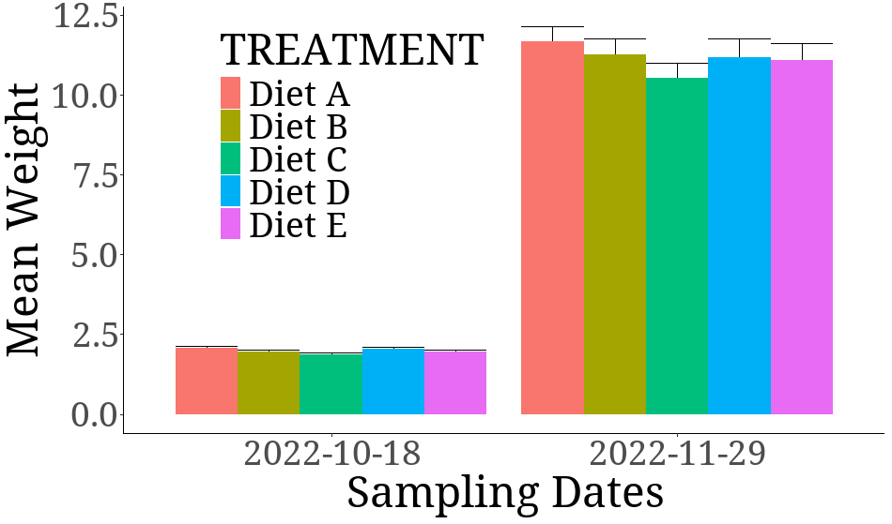

## Table

## GT

| Characteristic | Diet A, N = 1051 | Diet B, N = 1051 | Diet C, N = 1051 | Diet D, N = 1051 | Diet E, N = 1051 |
| --- | --- | --- | --- | --- | --- |
| INITIAL_WEIGHT | 2.06 ± 0.00 | 1.96 ± 0.00 | 1.87 ± 0.00 | 2.03 ± 0.00 | 1.96 ± 0.00 |
| FINAL_WEIGHT | 11.66 ± 0.00 | 11.25 ± 0.00 | 10.52 ± 0.00 | 11.18 ± 0.00 | 11.08 ± 0.00 |
| WEIGHT_GAIN | 9.60 ± 0.00 | 9.28 ± 0.00 | 8.65 ± 0.00 | 9.15 ± 0.00 | 9.12 ± 0.00 |
| DWG | 0.229 ± 0.000 | 0.221 ± 0.000 | 0.206 ± 0.000 | 0.218 ± 0.000 | 0.217 ± 0.000 |
| PERCENT_WEIGHT_GAIN | 466 ± 0 | 473 ± 0 | 463 ± 0 | 451 ± 0 | 465 ± 0 |
| SGR | 4.128 ± 0.000 | 4.155 ± 0.000 | 4.115 ± 0.000 | 4.064 ± 0.000 | 4.124 ± 0.000 |
| TFI | 113 ± 50 | 109 ± 50 | 105 ± 50 | 119 ± 62 | 97 ± 51 |
| AFI | 3.24 ± 1.44 | 3.11 ± 1.44 | 3.01 ± 1.43 | 3.39 ± 1.77 | 2.77 ± 1.46 |
| FCR | 0.34 ± 0.15 | 0.33 ± 0.15 | 0.35 ± 0.17 | 0.37 ± 0.19 | 0.30 ± 0.16 |
| 1Mean ± SD | | | | | |